- 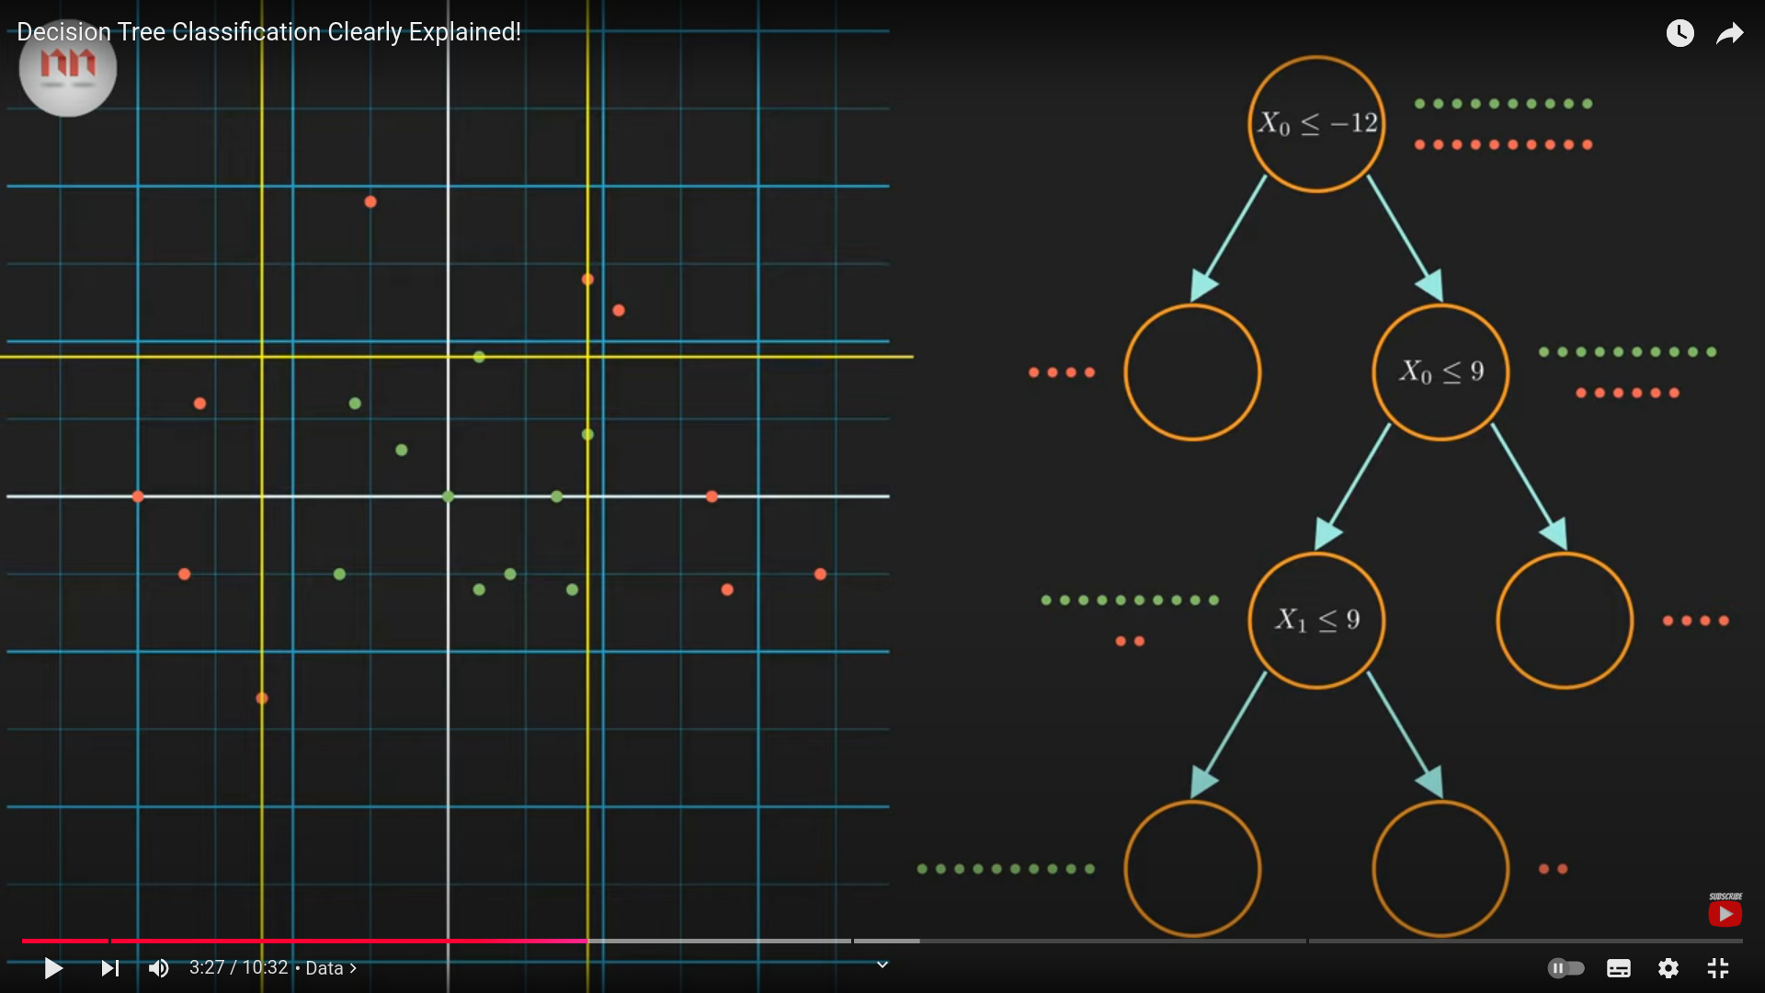
- The decision tree has 2 types of nodes and some important:
  - Decision nodes - criteria to split the node
  - Leaf nodes - decides the class
  - Usually the left child of the root, is agreeing the condition.
  - Right is not agreeing with the condtion node.

- Just have a look at white point with (15,7) point.

- 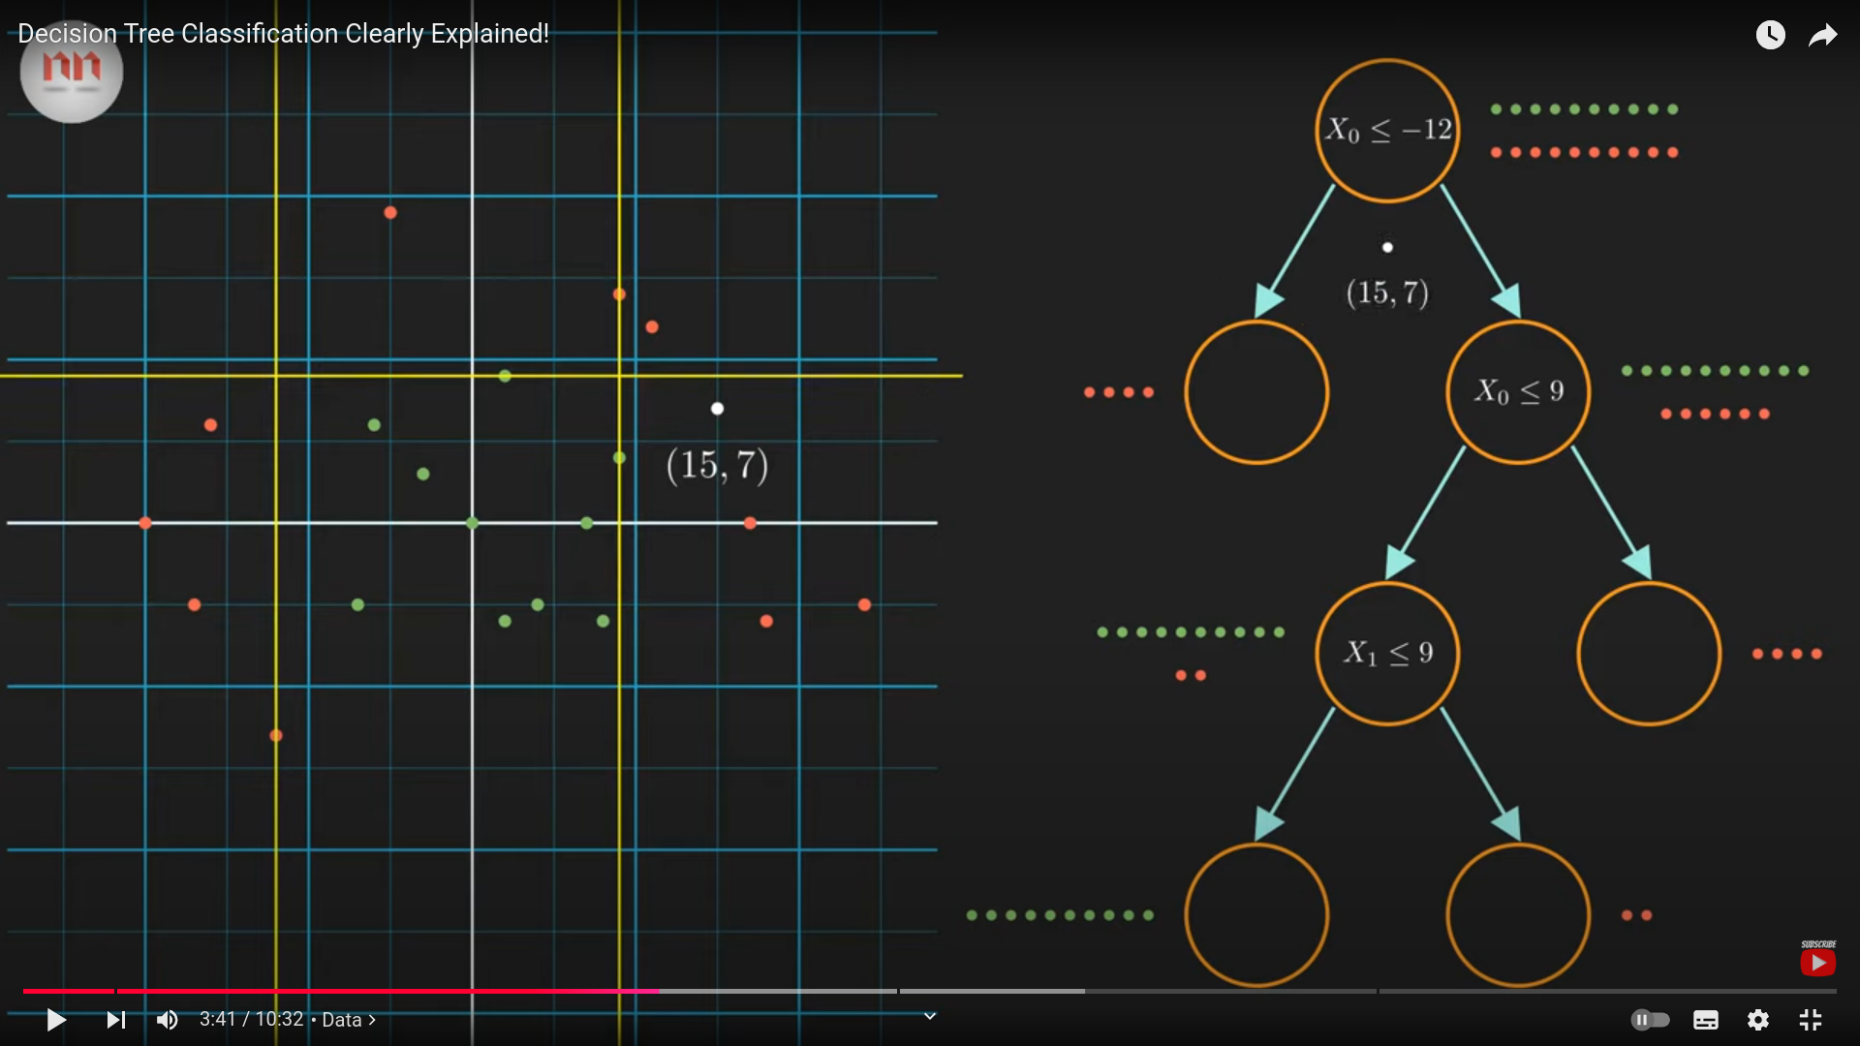
- 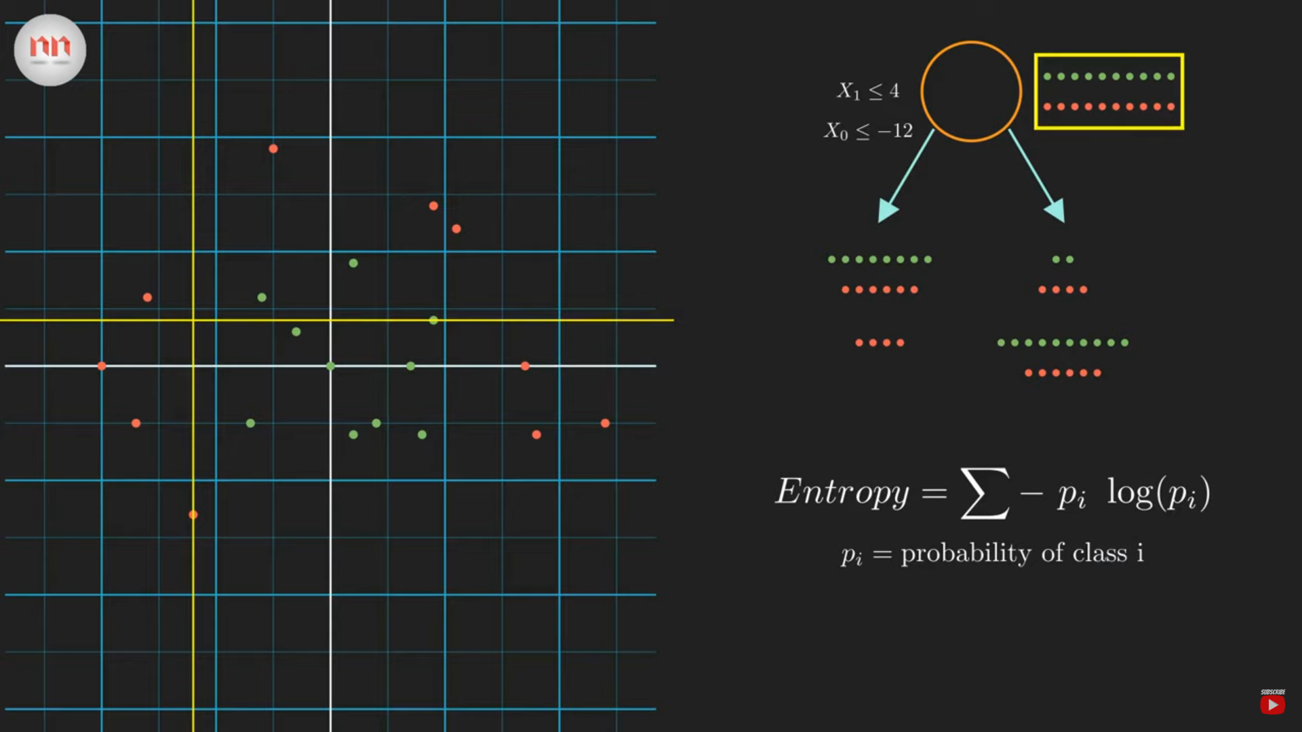
- The below is the way my whole space is splitted into 2 different classes.
- 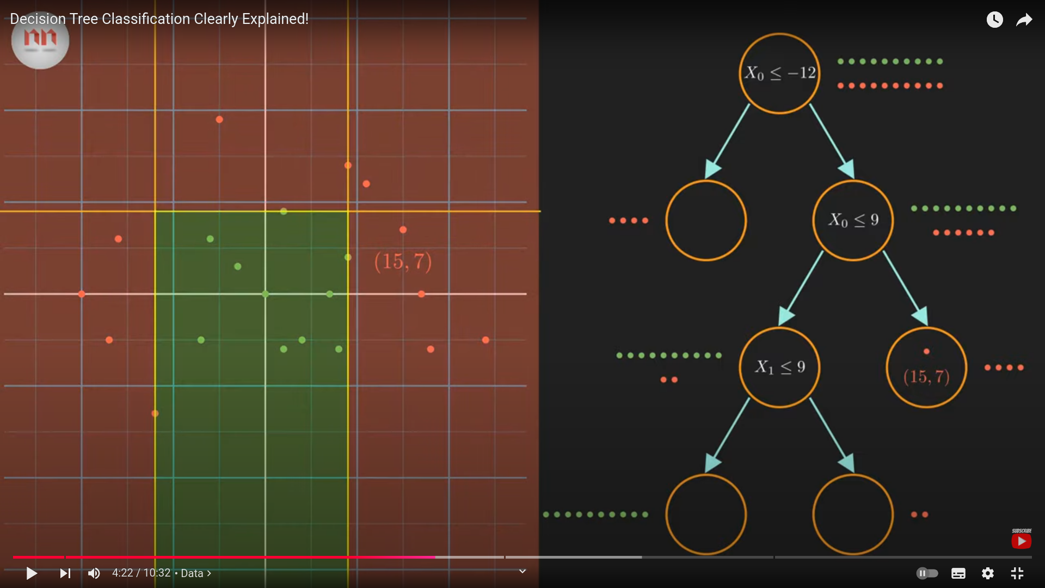
- Important things to be observerd:
  - The one column which has higher information gain is used for decision node classification, that column must have lower entropy
  - The higher the entropy means higher the shock.
  - Higher the shock means can’t predict anything properly, certain events that has to happen cannot be predicted without looking into it .
  - If I can guess what can happen in net move certainly then the entropy is 0 . Example: ( Pr(H) =1 and Pr(Tail) = 0 ), here the entropy is low.
  - Pr(h) = 0.5 and Pr(Tail) = 0.5, then entropy is 1 .
  - The one with the high entropy is going to produce the lesser information gain, since the formula states.
  - Decision Node psuedocode:
    - Considering all the unique values in the column.
    - The left split comes when the value comes in future is less than or equal to the unique value considered. The right split comes when the value is greater than the unique value considered at the decision node.
    - When coming to the left split , if we want further splits then we start considering other columns into consideration . Similarily it obeyed for right split too.
    - Based on the number of classes in the target, we need to have entropy of the node/split. Hence finally we will have evaluate for information gain of the node.
    - The information gain using above steps is calculated for every columns based on the splits. The one column with the highest information gain is considered for the splitting the node.
    - Once again based on the side the the data falls, the dataset is splitted again.
    - Once again above procedure starts to work, hence this is how the algorithm works.

- 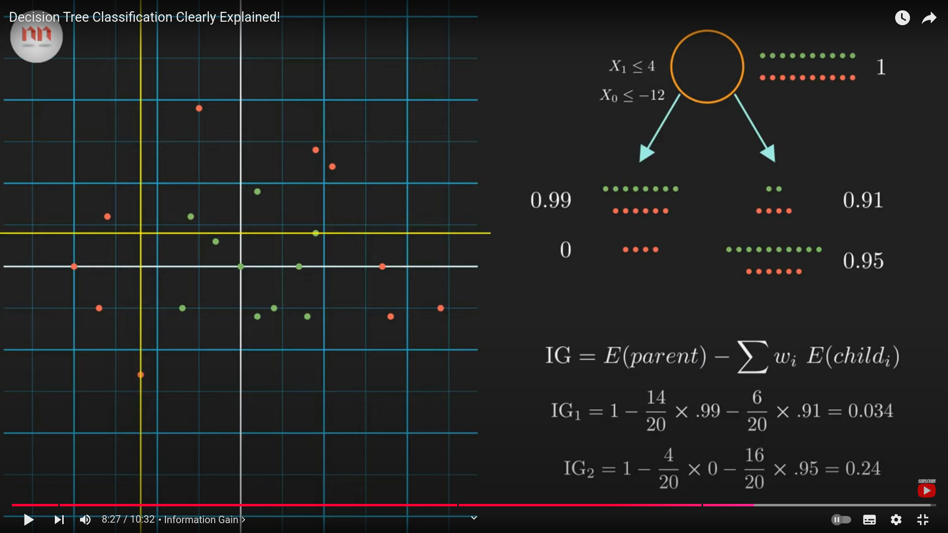
- 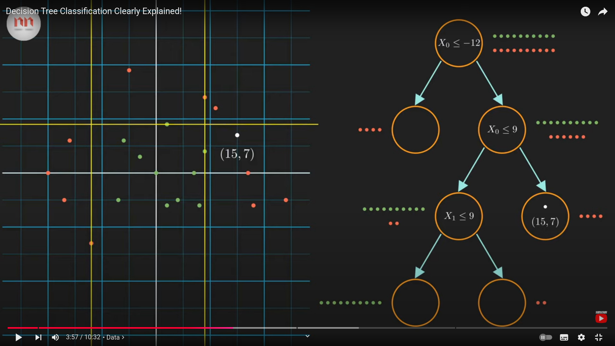
- The power of decision tree: it can handle the non-linear/ crazy datasets well, properly , which other algorithms make themselves hard to make it.

- Code Part
  - 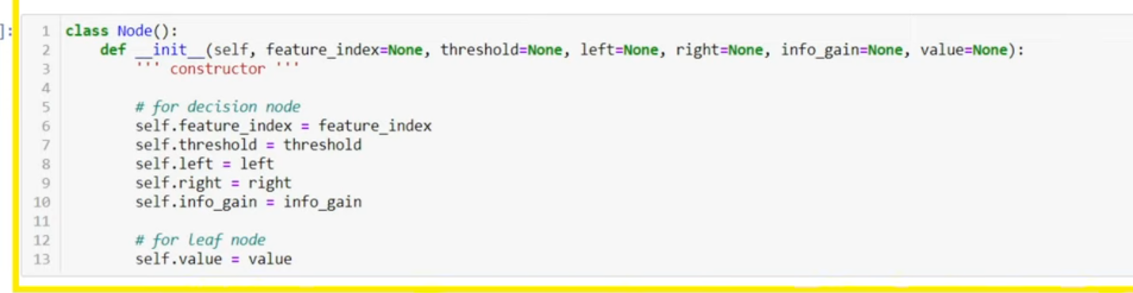
  - There are 2 types of Nodes, leaf node and decision node:

    - Decision Node:
      - feature index - is the column, under which the splitting is going to occur. Index is the column number.
      - threshold - the alue for which the node is splitted.
      - left - pointer which holds the left branch.
      - right - pointer which holds the right branch of the data.
      - info_gain - used to hold the information gain of the column that is splitted.
    - Leaf Node:
      - value - majority of the class under the roof, if mixture is present.
  - Decision Tree class:
    - Constructor(__init__):
      - 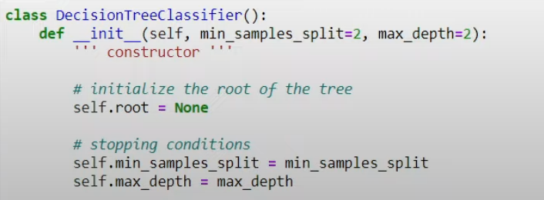
      - root - we need this root, to traverse throught the tree.
      - The other 2 are just the minimum conditions, so when these are met, the further splitting of the node is stopped.
        - min_samples_split: In a decision tree if the number of sample split is less the mentioned then further splitting will not occur. We consider this to be as leaf node.
        - If the depth of the tree reaches the maximum then also we don’t split it further.

    - Build Tree function:
      - 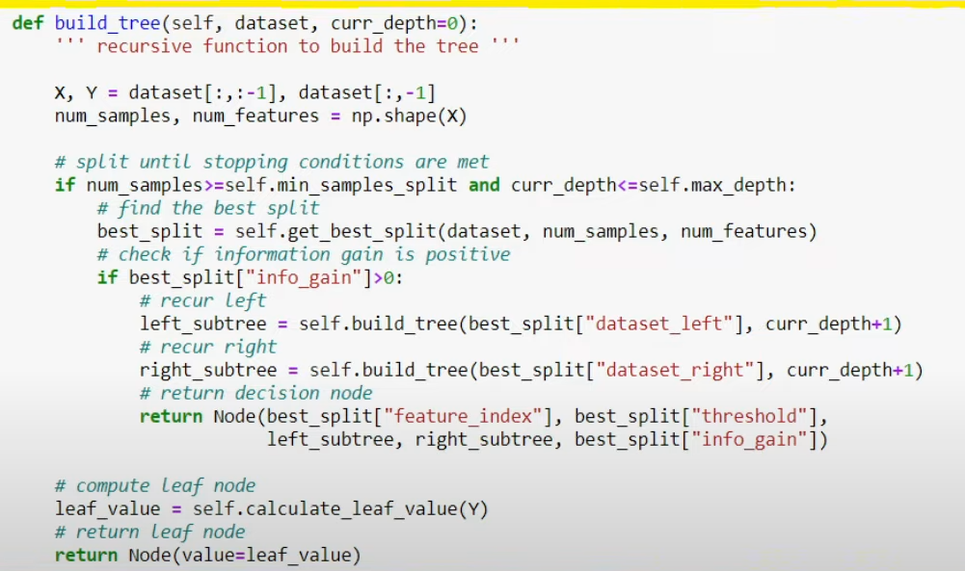
      - This is the reccursion function to build the reccursion tree using build function.
      - Split the dataset into x(features) and y(targets).
      - Decision Node Build:
        - Decision node
        - The condtion has to met, if the conditions are not met, then we do not even consider for further splitting of the node.
          - There must be minimum number of samples to split, else we do not split further.
          - The maximum depth is necessary, if the maximum depth has reached then also we do not even consider for splitting the node further.
          - So any one of the above 2 conditions do not meet, then we do not even consider for further splitting.

        - If the conditions do not met, means then we are in leaf node.
        - If the information gain = 0, we have reached a place where purity is met.
        - else:
          - best_split further, check and rest is understandable.

      - Leaf Node:

    - s

- 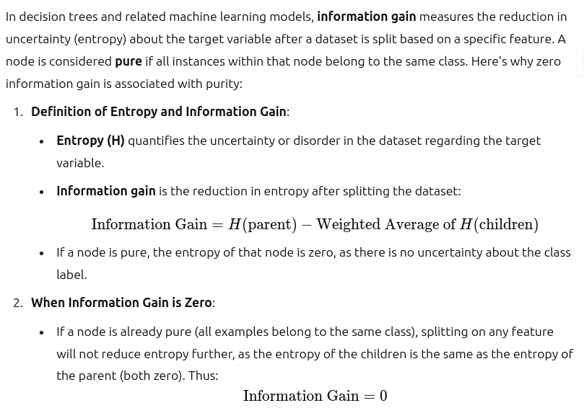

- s

